<https://twiki.cern.ch/twiki/bin/view/CMSPublic/SWGuideCrab>

<https://sites.google.com/a/physics.umd.edu/cmsanalysis/home/analysis-steps>

<https://twiki.cern.ch/twiki/bin/view/CMSPublic/CRAB3AdvancedTopic>

<https://twiki.cern.ch/twiki/bin/view/CMSPublic/SWGuideCrab>

<https://twiki.cern.ch/twiki/bin/view/CMSPublic/SWGuideCrab>

<https://twiki.cern.ch/twiki/bin/view/CMSPublic/CRAB3TaskFlow>

<https://twiki.cern.ch/twiki/bin/view/CMSPublic/Crab3HtcondorStates>

<https://twiki.cern.ch/twiki/bin/view/CMS/SWGuideCMSDataAnalysisSchoolJetMetAnalysis>

<https://twiki.cern.ch/twiki/bin/view/CMS/SWGuideCMSDataAnalysisSchoolPisa2019PPDExercise>

For data and MC on SL6 or SL7 systems:

ssh aalkadhi@lxplus.cern.ch

cmsrel CMSSW\_10\_2\_18

cd CMSSW\_10\_2\_18/src

CONDCORE ERROR

**https://twiki.cern.ch/twiki/bin/view/CMSPublic/SWGuideHiCentTroubles#Connection\_on\_sqlite\_file\_afs\_ce**

**Invalid CRAB configuration: In case of Automatic splitting, the Data.unitsPerJob parameter must be in the [180, 2700] minutes range. You asked for 30 minutes ---** here unitsperjob was set to 30, I thought units per job was the # of files per job, not minutes!

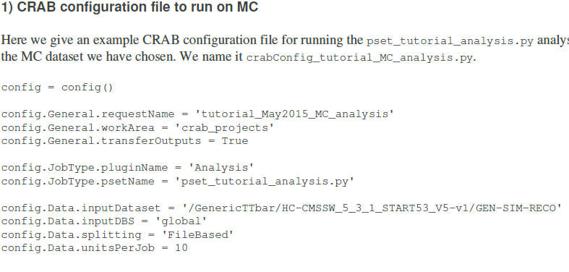



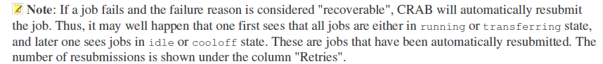

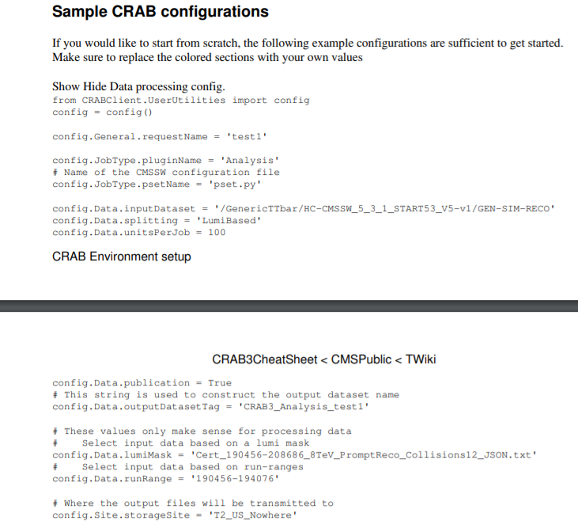

Crab log files

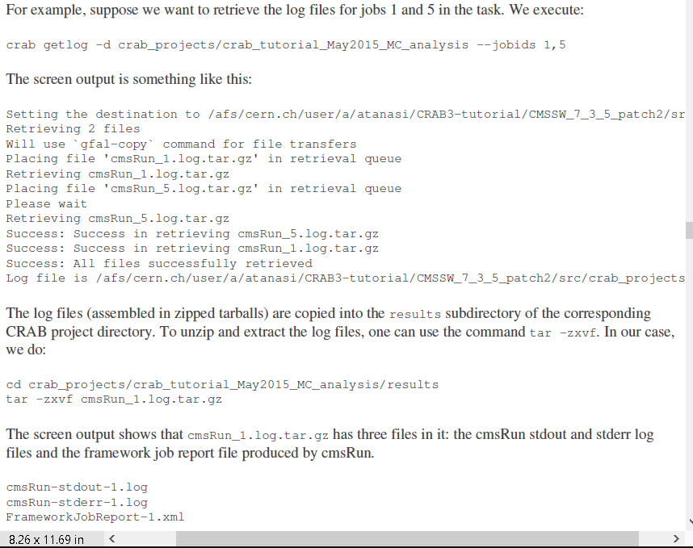

Get the output root files



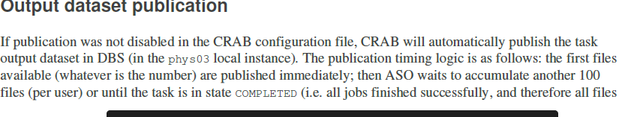

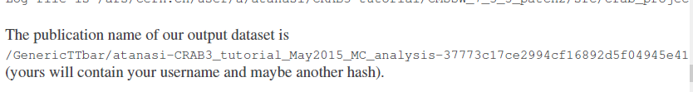

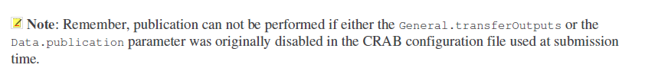

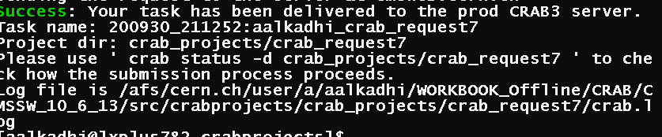

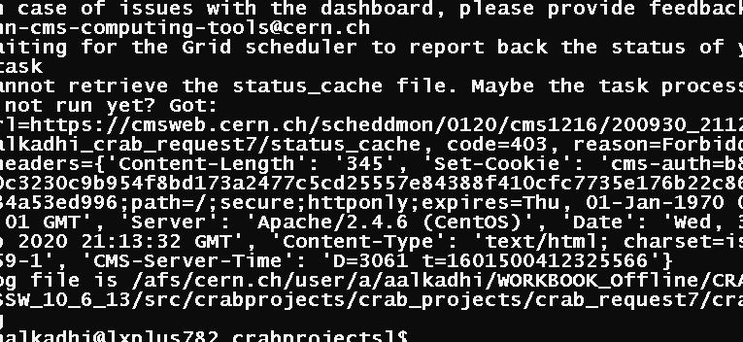

crab submit -c crabConfig\_tutorial\_MC\_analysis.py

we should aim at 8 hrrs per job

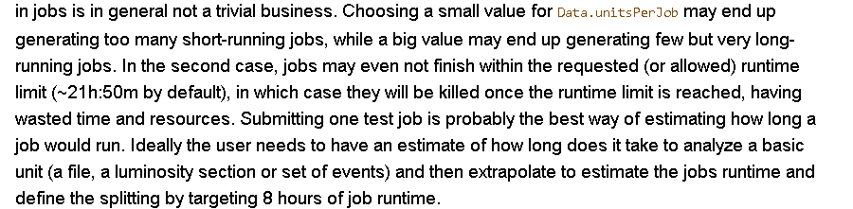

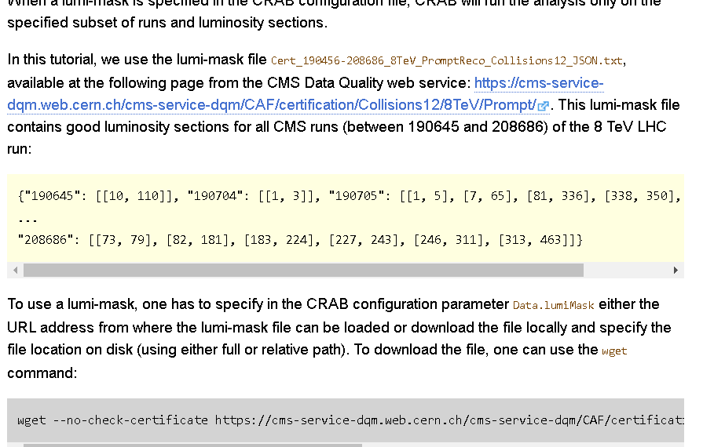

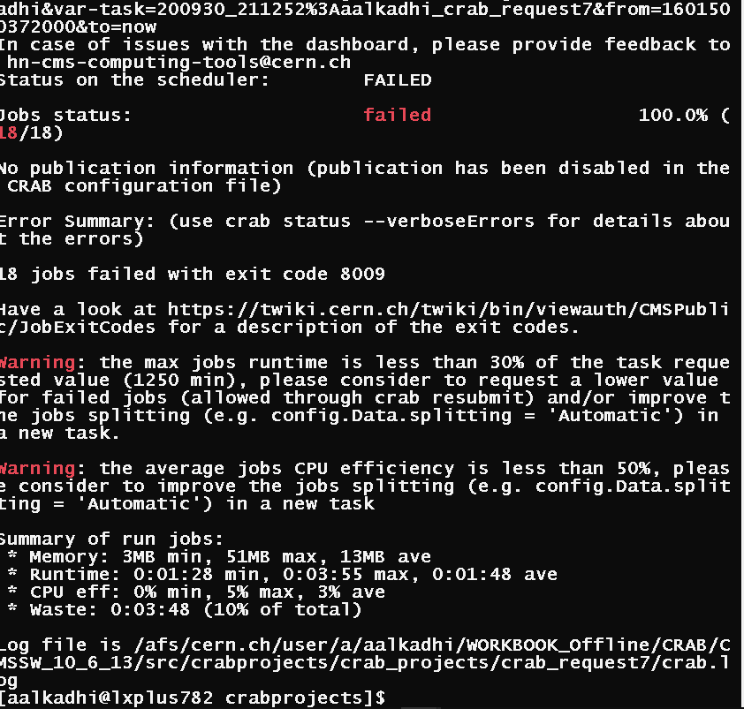

crab status -d crab\_projects/crab\_request7

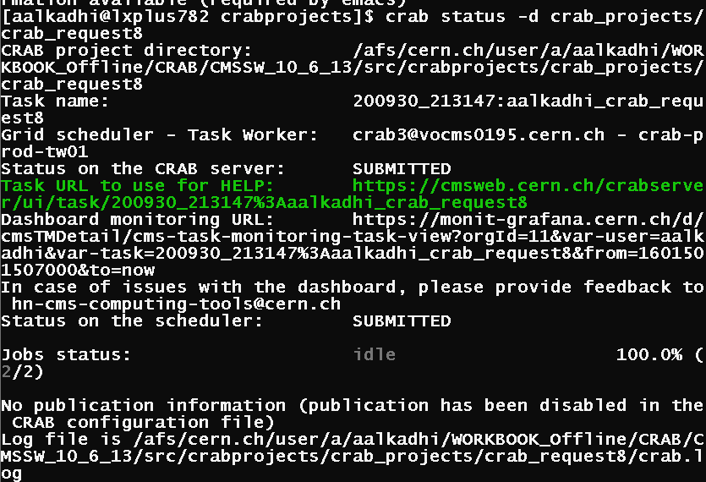

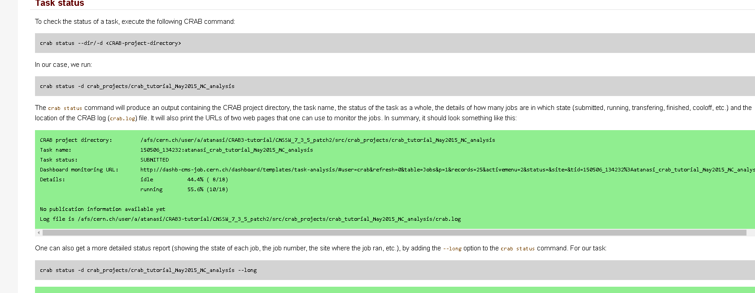

8002 error: bad allocation (on file inut) and crash.

IT still crashes with 8002 even without my class!!!! So it’s not my code cause it to fail

[https://twiki.cern.ch/twiki/bin/view/CMSPublic/Crab3DataHandling#Logical\_File\_Names\_of\_output\_and](https://twiki.cern.ch/twiki/bin/view/CMSPublic/Crab3DataHandling" \l "Logical_File_Names_of_output_and)

<https://twiki.cern.ch/twiki/bin/view/CMSPublic/WorkBookCRAB3Tutorialhttps://twiki.cern.ch/twiki/bin/view/CMSPublic/CRAB3Commands>

<http://www.crc.nd.edu/~awoodard/lobster/merge_v4c/logs/1789/cmssw.log>

<https://github.com/lathomas/JetMETStudies/blob/master/README.md>

<https://raw.githubusercontent.com/NEUAnalyses/HHWWgg_Tools/b5b65f6cd44989e6790afbbf1816c2ab7b1b256a/HHWWgg_NMSSM/bbbb_Files/NMSSM_XYH_bbbb_DIGI_cfg.py>

<https://github.com/hh-italian-group/hh-bbtautau/wiki/ProdV4>

[https://twiki.cern.ch/twiki/bin/view/CMSPublic/CRAB3FAQ#crab\_status\_says\_that\_Task\_is\_FA](https://twiki.cern.ch/twiki/bin/view/CMSPublic/CRAB3FAQ" \l "crab_status_says_that_Task_is_FA)

<http://twiki.ihep.ac.cn/twiki/view/CMS/Crabguide>

<https://twiki.cern.ch/twiki/bin/view/CMSPublic/WorkBookRemoteSiteSpecifics>

check the data is at which sites in das

[https://twiki.cern.ch/twiki/bin/view/CMSPublic/CRAB3Commands#crab\_checkwrite](https://twiki.cern.ch/twiki/bin/view/CMSPublic/CRAB3Commands" \l "crab_checkwrite)

<https://twiki.cern.ch/twiki/bin/view/CMSPublic/WorkBookCRAB3Tutorial>

<http://mitchcomp.physics.tamu.edu/mitchcomp/guides/admin/CATS_debug.pdf>

SITE LIST

https://cmsweb.cern.ch/phedex/prod/Request::Main